A.A.GOVERNMENT ARTS COLLEGE, MUSIRI AFFILIATED TO BHARATHIDASAN UNIVERSITY, TIRUCHIRAPPALLI.

NAAN MUDHALAVAN PROJECT-III BSC MATHEMATICS

Unlocking Insights into the Global Air Transportation Network

Submitted By TEAM ID: NM2023TMID08307 TEAM

LEADER:PRAKASH:(A29E4DD3B0DF35BB796480F2D4C3D3C1)

MEMBERS: CHANDRU.C (90831C1218344CF80404B913E3897963): HARISH.C (07A6C064F7C031FAC8D4895B8C78AF4B): SIBIRAJ.V (24F09853FAC654A9575496FB0D48A4E8)

INTRODUTION

The right data, harnessed in the right way, can deliver actionable insights that are truly transformative for decision-marking, efficiency and smooth passenger-focused delivery of services. Jim Peters, Chief Technology Officer at SITA, reveals how big data is beginning to deliver real value in the air transport industry. You can already see many examples of where data-driven business intelligence (BI) initiatives are transforming the way things are done in the air transport industry. Investment in BI is critical if the maximum value is to be obtained from the vast volumes of data increasingly available to airport and airline management. It’s about capturing, collating and, importantly, analyzing the data. That’s what leads to greater productivity, effectiveness and, ultimately an enhanced customer service.

EMPATHY MAP BRINSTROMING MAP

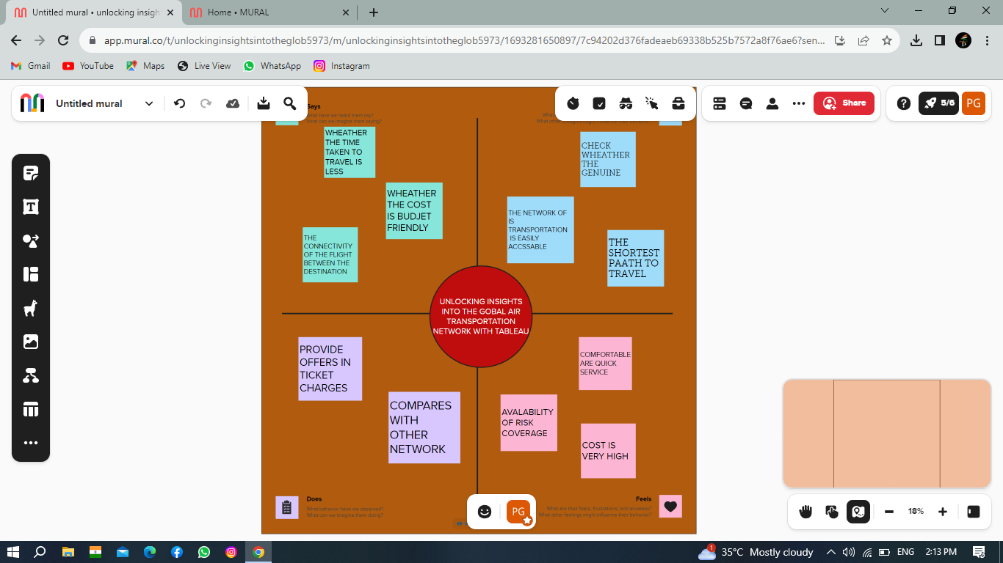

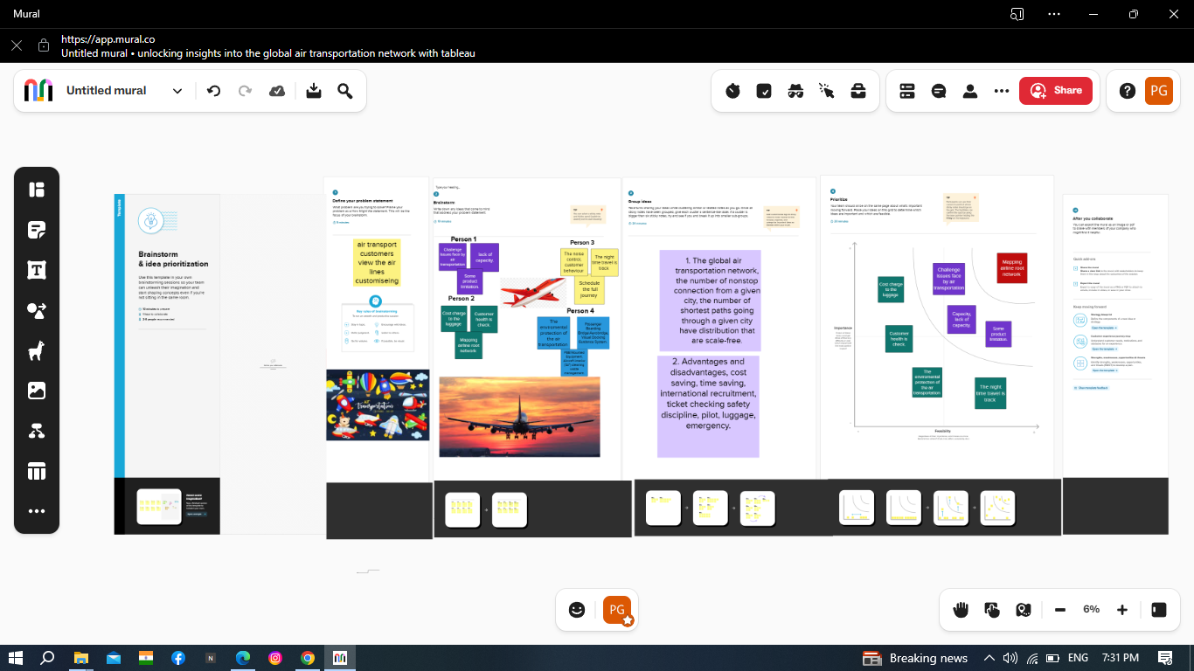

DATASET CONNECT TO TABLAUE



VISHVALATION 1

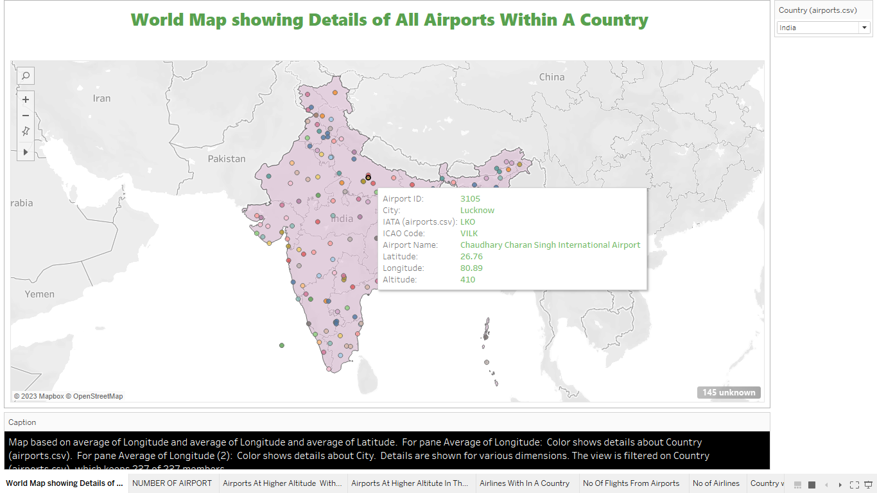

VISHVALATION 2

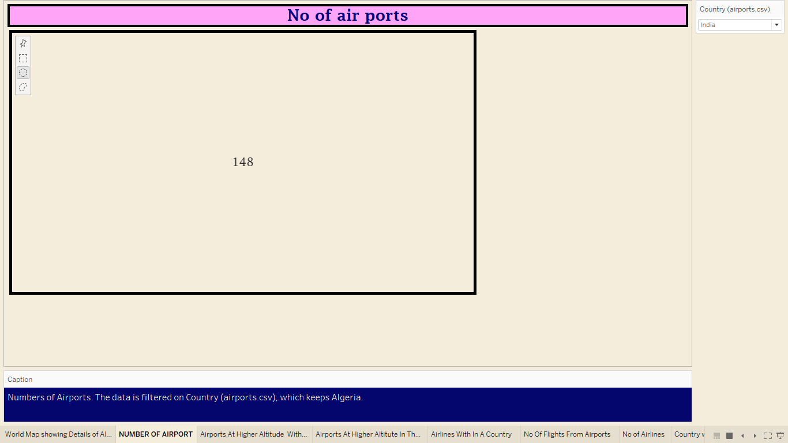

VISHVALATION 3

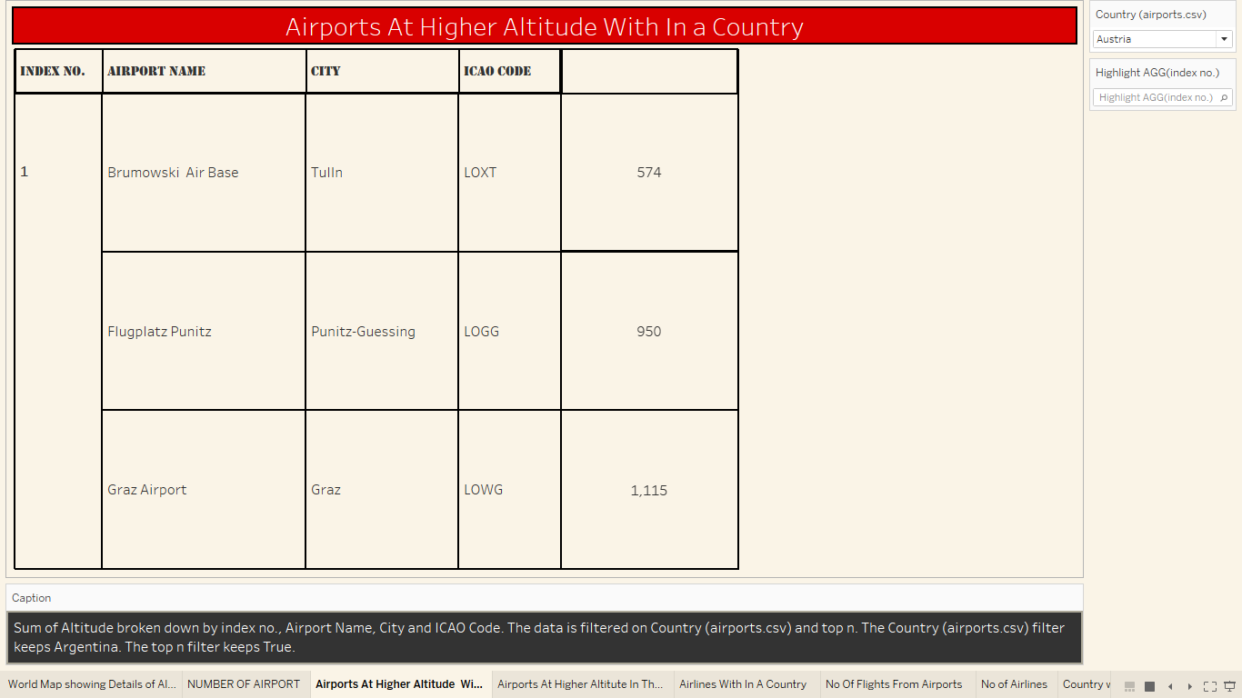

VISHVALATION4

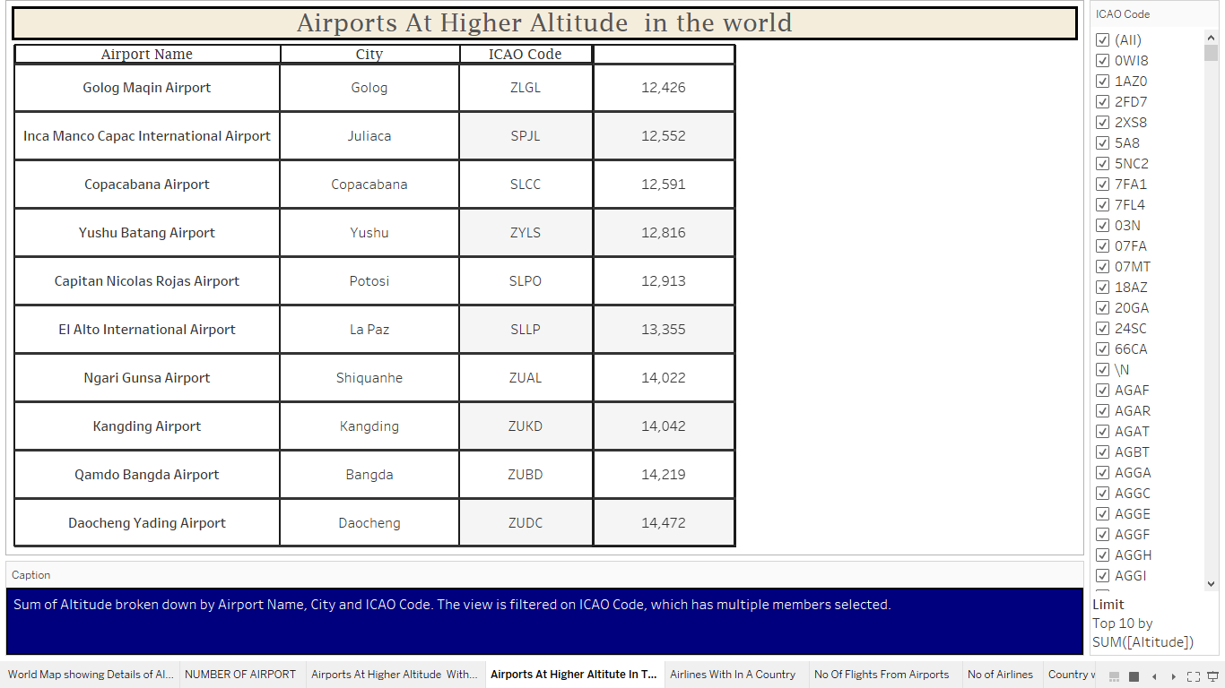

VISHVALATION 5

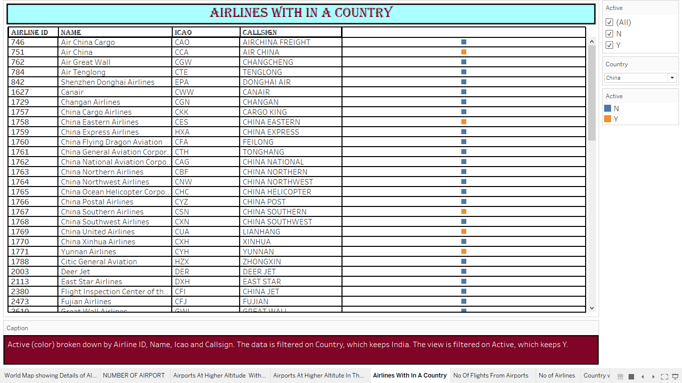

VISHVATION 6

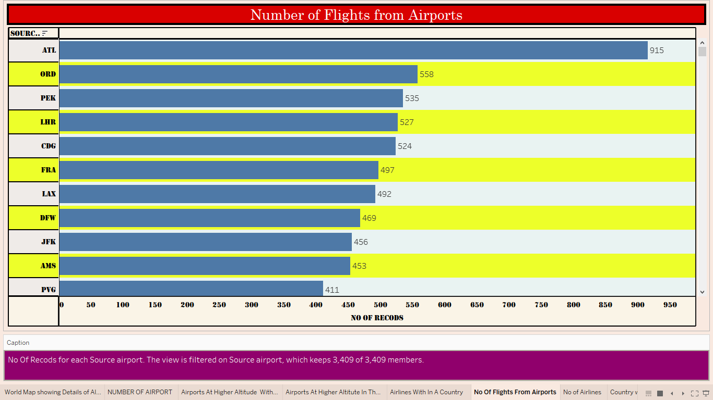

VISHVALATION 7

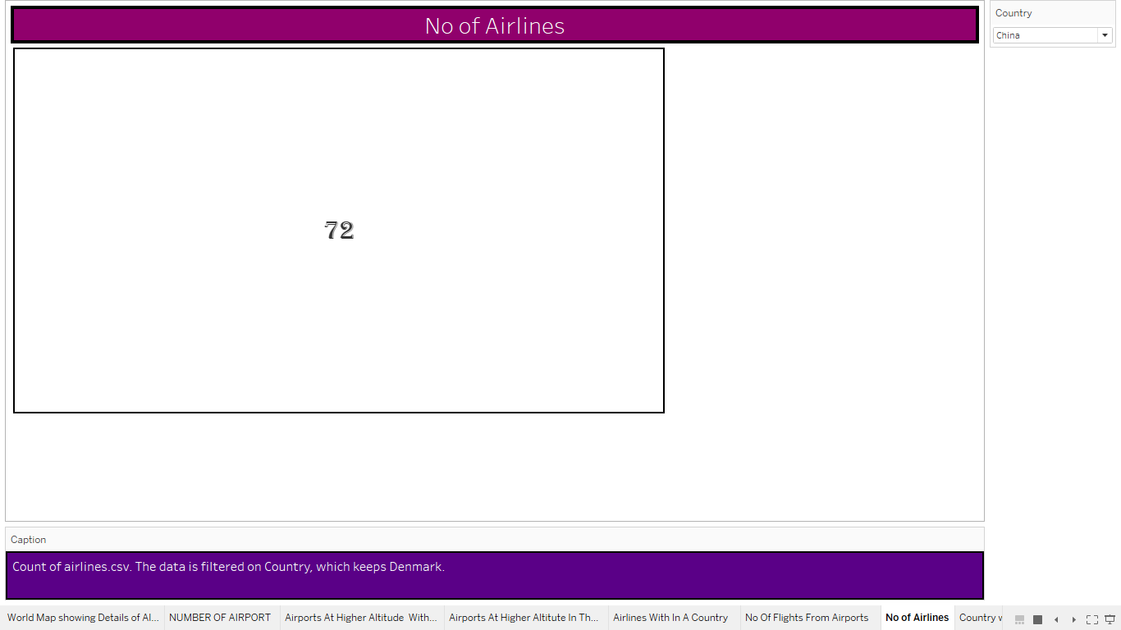

VISHVALATION 8

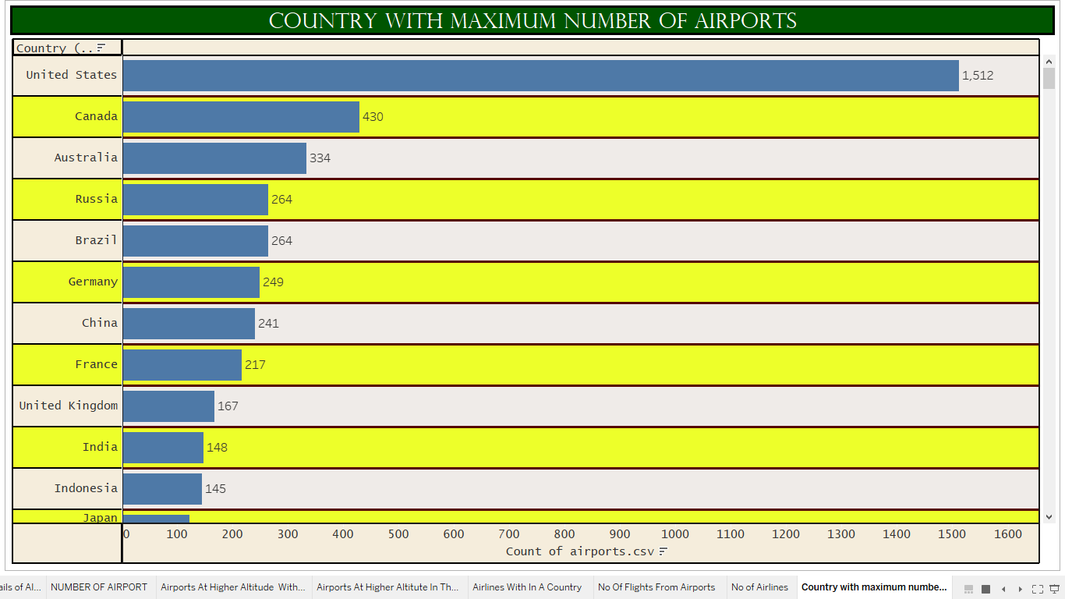

DASHBOARD 1

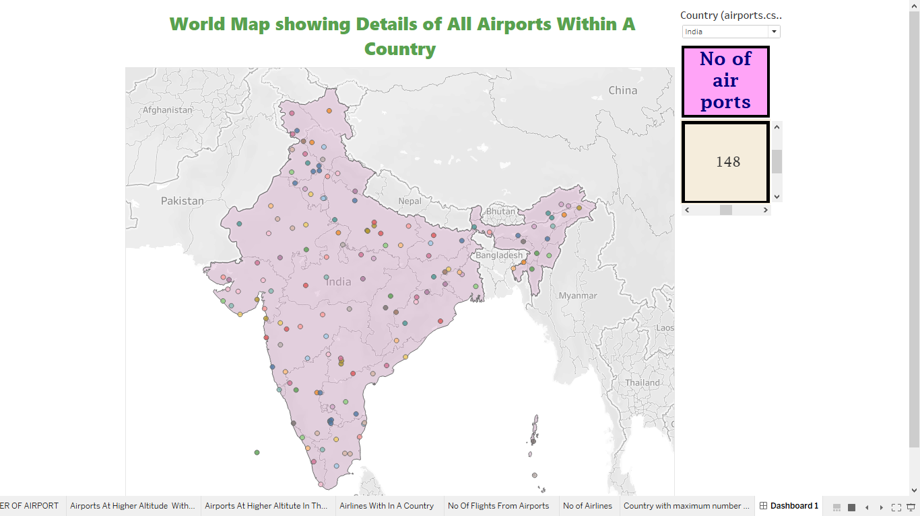

DASHBOARD 2

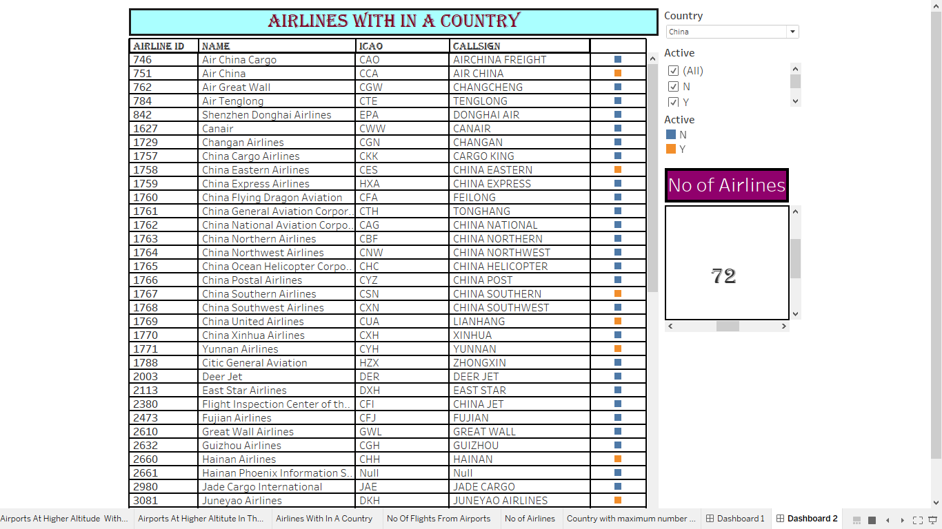

DASHBOARD 3

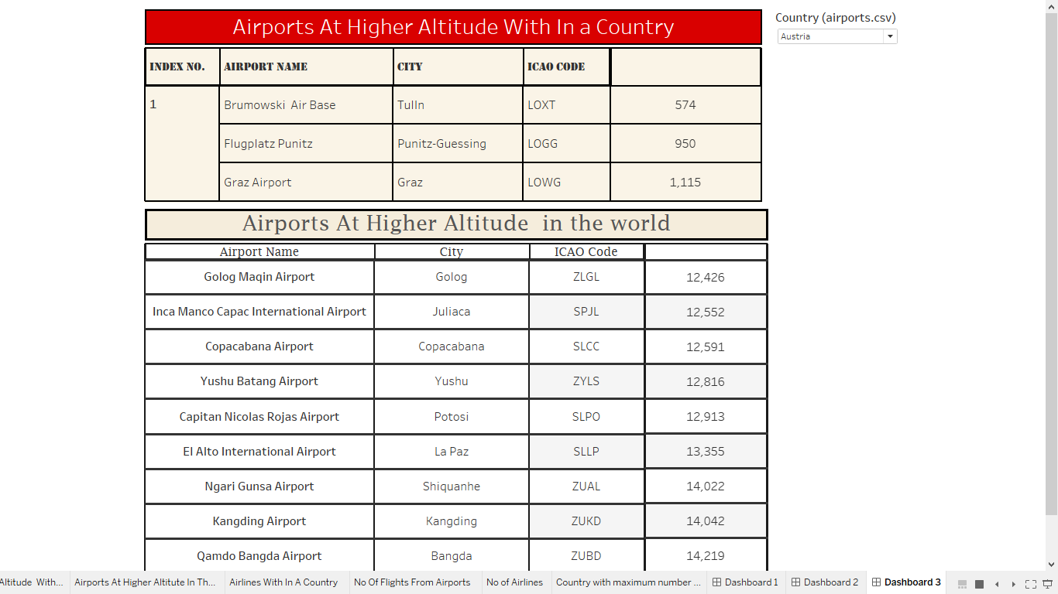

DASHBOARD 4

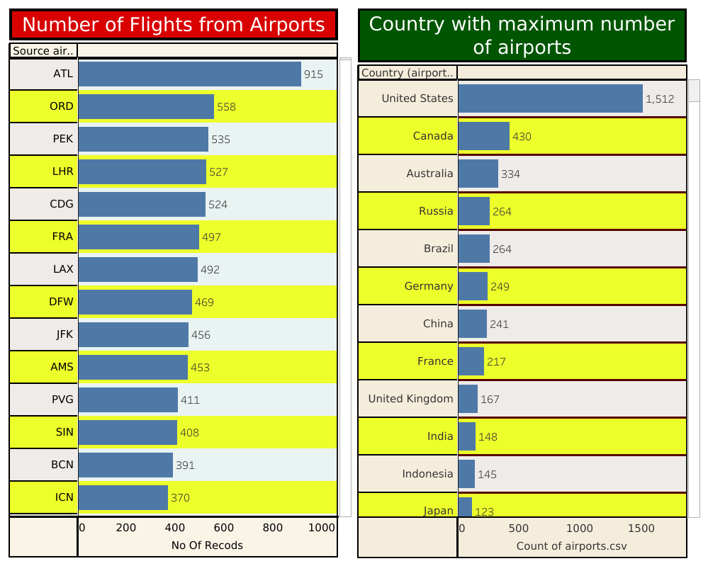

Story

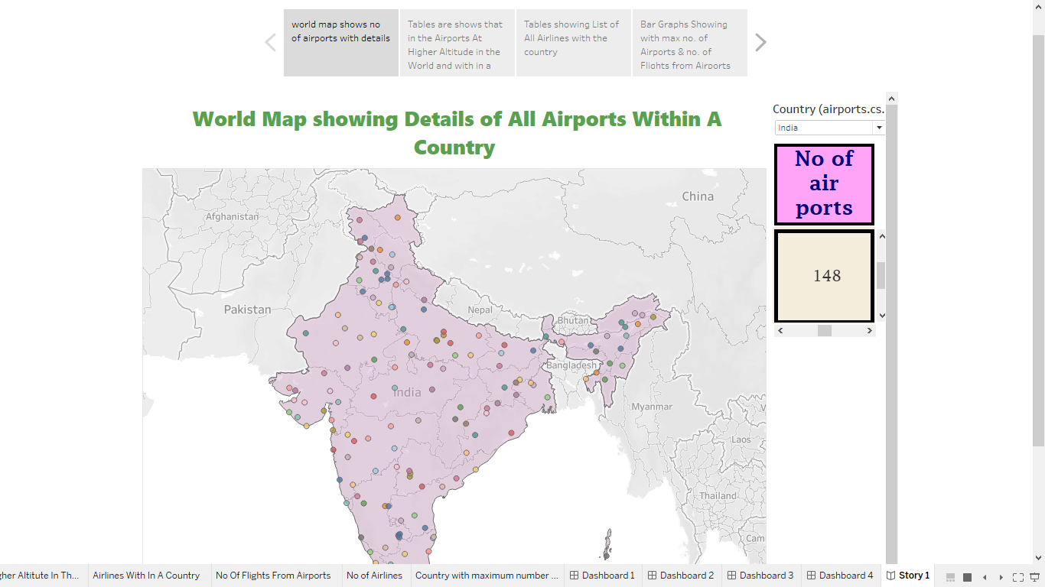

PUBLISHING

Dashboard 1 Link https://public.tableau.com/views/dashboard1_16951801058130/Dashboard1?: language=end-US&:display count=n&:origin=viz_share_link

Dashboard 2 Link https://public.tableau.com/views/dashboard2_16951805421880/Dashboard2?: language=en-US&:display_count=n&:origin=viz_share_link Dashboard 3 Link https://public.tableau.com/views/dashboard3_16951809944580/Dashboard3?: language=en-US&publish=yes&:display_count=n&:origin=viz_share_link

Dashboard 4 Link https://public.tableau.com/views/dashboard4_16951818527580/Dashboard4?: language=en-US&publish=yes&:display_count=n&:origin=viz_share_link

STORY LINK https://public.tableau.com/views/UnlockingInsightsIntoTheGlobalAirTransporta tionNetworkWithTableau/Story1?:language=enUS&:display_count=n&:origin=viz_share_link

CONCLUTION

We analyzes the global structure of the worldwide air transportation network, a critical infrastructure with an enormous impact on local, national, and international economies. We find that the worldwide air transportation network is a scale-free small-world network. In contrast to the prediction of scale-free network models, however, we find that the most connected cities are not necessarily the most central, resulting in anomalous values of the centrality. We demonstrate that these anomalies arise because of the multicommunity structure of the network. We identify the communities in the air transportation network and show that the community structure cannot be explained solely based on geographical constraints and that geopolitical considerations have to be taken into account. We identify each city's global role based on its pattern of intercommunity and intracommunity connections, which enables us to obtain scale-specific representations of the network.